**Project Design Phase-I**

**Solution Architecture**

| Date | 19 May 2023 |
| --- | --- |
| Team ID | NM2023TMID13113 |
| Project Name | Reducing-the-Environmental-Footprint-of-Food-A-Comprehensive-Management-system |

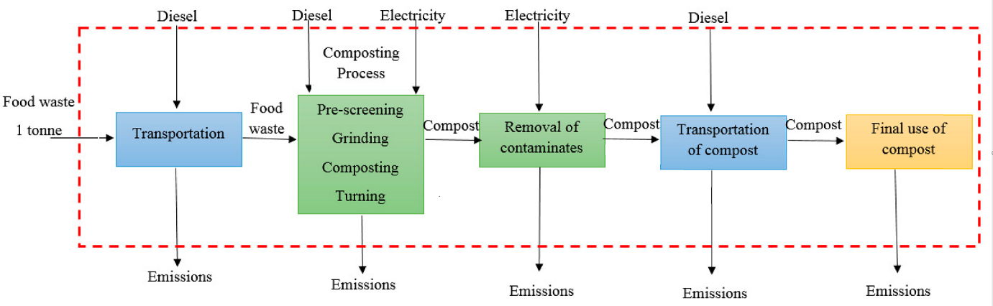

**Reducing Food Environmental Footprint**

**To reduce the environmental footprint of food, a comprehensive management system can be implemented. Here is a solution architecture that outlines the key components and their interactions:**

**Data Collection:**

**Sensors and IoT devices can be deployed across the food production and supply chain to collect real-time data on various parameters such as energy consumption, water usage, greenhouse gas emissions, and waste generation.**

**Data can also be collected from external sources such as weather forecasts, market demand, and transportation routes.**

**Data Processing and Analysis:**

**The collected data is transmitted to a centralized system or cloud infrastructure for processing and analysis.**

**Data analytics techniques, such as machine learning and statistical modeling, can be used to identify patterns, trends, and areas of improvement.**

**Environmental Impact Assessment:**

**Using the processed data, an environmental impact assessment can be conducted to quantify the carbon footprint, water footprint, and other environmental indicators associated with different stages of food production, processing, packaging, transportation, and waste management.**

**Decision Support System:**

**Based on the environmental impact assessment results, a decision support system can provide recommendations and guidance to stakeholders in the food industry.**

**The system can suggest strategies and actions to reduce environmental impact, optimize resource usage, and improve sustainability, considering factors like cost, feasibility, and regulatory compliance.**

**Supply Chain Optimization:**

**The management system can optimize the food supply chain by integrating various components like inventory management, logistics, and transportation.**

**It can identify opportunities for reducing transportation distances, improving route efficiency, and minimizing food waste through better demand forecasting and inventory management practices.**

**Stakeholder Collaboration:**

**The system can facilitate collaboration among different stakeholders, including farmers, food producers, processors, retailers, and consumers.**

**Stakeholders can share information, best practices, and success stories, fostering a culture of sustainability and innovation in the food industry.**

**Monitoring and Reporting:**

**Real-time monitoring of environmental performance metrics can be implemented to track progress and ensure compliance with sustainability goals.**

**Reports and dashboards can be generated to communicate the environmental performance of different entities within the food value chain, promoting transparency and accountability.**

**Continuous Improvement:**

**The comprehensive management system should be designed for continuous improvement and adaptation.**

**Feedback mechanisms, data-driven insights, and stakeholder feedback can drive iterative enhancements to the system, enabling it to evolve and address emerging challenges.**

**By implementing this solution architecture, the food industry can effectively manage and reduce its environmental footprint, contributing to sustainable food production and consumption practices.**